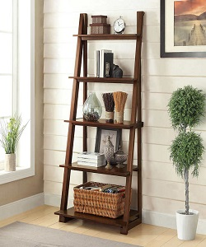

Universal Modern Bookcase

$75.49

Availability: In stock

**Description:**

Blending the charm of farmhouse aesthetics with modern minimalism, this understated bookcase brings on-trend style to any space in your home. While its clean lines and open design ensure it won't overwhelm an existing arrangement. Craft frame, this budget-friendly piece features five tiers made from manufactured wood in a natural finish, each with a weight capacity of 30 lbs. that are perfect for housing linens, cookbooks, or a decorative display. Assembly is required.